**‘Wirecutters’ Sound Design**

**By Jordan McCrae**

**Ambience:**

* For the wind, I used a low-pass filter before the opening scene to create more impact for when the first scene opens; with the change from quieter, low-passed wind to full force wind, in sync with the opening picture. I did the opposite when transitioning to the next scene (desolate planet), to help gradually shift the viewer from watching one landscape to watching another. The low-pass filter and gradual decrease in volume is used here to represent the camera moving away from the wind/parachute, and towards the ground level.
* I also used a random perlin oscillator to help add to the realism of the ‘noise’ sounding wind – as wind is not predictable and does not oscillate in sine waves (as the LFO is doing), therefore the random oscillator counteracts the repetitiveness of the sine wave LFO.
* I deliberately copied the timbre of the synth ‘Violin’ like atmosphere sound for the foley of the ‘gem machine’ humming to create an effect which blurs the line between what is ‘real’/diegetic and what is not/non-diegetic, emphasizing the isolation and loneliness of this desolate planet for the viewer.
* I reversed the ‘Atmospheric Sounds High End’ for its second repeat to create variation for the ambience – further adding to the unpredictable nature of the ambience, helping to keep the viewer engaged.

**Music:**

* I used a synth with a gradual pitch riser to build tension towards the big robot discovering the small robot (when they first meet). This helps further immerse the audience in the shock that the big robot experiences when he discovers the small robot hiding. I also deliberately cut off the riser sound when the small robot pops up from behind the container. This was for a comical effect, where the sudden silence in music (ie: the ‘tension’ sound) makes the small robot popping up on screen much more amusing for the audience.
* I deliberately included ‘Dies Irae’ at 7:12. This was to foreshadow the event of the big robot dying/being taken away in the wind, which happens about 20 seconds after he is trapped between the gem machine and the parachute pulling him towards the sky.

**Sound Effects:**

* The ‘scanner’ sound was deliberately played at an Bb note. This was to transition more smoothly from the background music (which ends on a Bb minor chord), again blurring the line between real world/diegetic sounds and background music/non-diegetic sounds – helping to further immerse the viewer in the isolation and loneliness of this planet (which the robot also experiences).
* I used a ‘tremolo’ on the gem scanning sound to create a sense of urgency and focus (for the viewer) when the small robot sees a gem with his scanner. This helps the viewer understand the importance of picking up gems early on in the short film – where the increased tremolo rate (when gems are nearby as the robot is scanning) signifies this importance aurally. It also leans into the ‘beeping when the target is nearby’ trope of a scanner to make this concept clearer for the viewer.

**Foley:**

* I used a combination of two sounds to replicate the small robot’s metal body movement. **These two sounds consisted of:**

1. A toiletries bag with some empty soap, shampoo and toothbrush containers inside it. This was used to produce the **lows**, **mids**, and **some high end** of the movement sound, and provide some randomness in the containers movement to reproduce a more detailed, realistic and unpredictable sound of ‘metal’ parts moving inside the small robot’s body. The low end of this sound was also boosted (around 200Hz) to provide more of a resonating ‘boom’ to the sound, representing the hollow, reverberant nature of the robot’s metal body.
2. For some of the **mids** and **high** end of the sound, I used a ‘crunch’ sound created from squishing a ‘Cetaphil wipes’ packet. This sound again produced lots of unpredictable ‘movement’ sounds which nicely complimented the sound of the containers in the toiletries bag. I also low-passed (at about 4900Hz) this sound to remove some of the very high-end crunch, which was too harsh and cut through the mix too much to take away from the realism of the robot movement sound. However, the high end of the ‘containers in toiletries bag’ sound was boosted, balancing out the overall sound so that it still had a large frequency range (that included high ends) and did not become muffled or ‘too’ low-passed.

* For the wire being reeled in (1:12), I deliberately looped the ‘Wire Being Reeled In (Machine)’ sound so that you would hear the restart of the loop (ie: not a perfect loop). This is to make the ‘swivel’/reel sound more realistic, where like a machine it has cycles and restarts each time the reel reaches a full cycle/360 degrees. By deliberately cutting the loop off, you can hear the restart which sounds like the beginning of a new ‘cycle’ of the reel spinning – giving it a much more realistic sound.
* For the claw movement at 1:57 (in the small ‘cave’ like space), I used a low pass filter before the robot is visible to the viewer. This is to imitate the camera being inside the cave, where only the low frequencies can be heard as the robot is nearing its entrance – until once it is in full visible sight, the entire audible (human) frequency spectrum (20-20,000Hz) can be heard again.
* For many of the foley sounds (such as smashing rocks, the small robots body/head movement, and the small robots claw sound), I would use slight variations through transposing the same sound recording (often by 1-3 semitones. This removed the static and audibly fake nature of the exact same sound being repeated – where transposing the sound shifted the frequencies of some of the harmonics, whilst also slightly changing the pitches between each of these repeated events (such a claw movement, or the small robot moving its head) Although sometimes these were very subtle change, overall it gave many of the foley sounds (especially the small and large robot’s movement sounds) a much more organic, and natural feel (ie: slight variations of pitch and harmonics for the same movement/action) to listen to.
* I also deliberately low passed most of the foley sounds during wide angle camera shots (ie: from a distance). This was to imitate how in real life the more prominent, low frequencies that travel further/can be heard from a distance, and the higher frequencies less so. I therefore often silenced many of the higher frequencies (and sometimes boosted the lows) – giving each foley sound a much more realistic feel, as if the viewer was actually watching these robots from a distance during these shots.
* For a lot of the big robot ‘rock smashing’ sounds, these are deliberately close to being clipped, if not clipped (very occasionally). This is to demonstrate the raw power applied by the big robot when the rock is being smashed, where if the camera was that close to the sound of the rocks breaking, this would likely create some large smashing sound which may even be distorted within the video (or distorted within the ear drum if a person was observing this from the camera’s exact position). It emphasizes the explosive nature of the rock breaking into hundreds of pieces (bigger and smaller ones), where this fully immerses the viewer in the scene; often from the perspective of the smaller robot, where this loud ‘smash’ shows the contrast between the big robot’s power and size versus that of the smaller robot (ie: less power and size).

**Photos of Objects Used:**

For the wire snapping/breaking sound at 7:17, 7:31 and 7:37, I used a combination of a **paper** ripping sound and **celery** breaking:

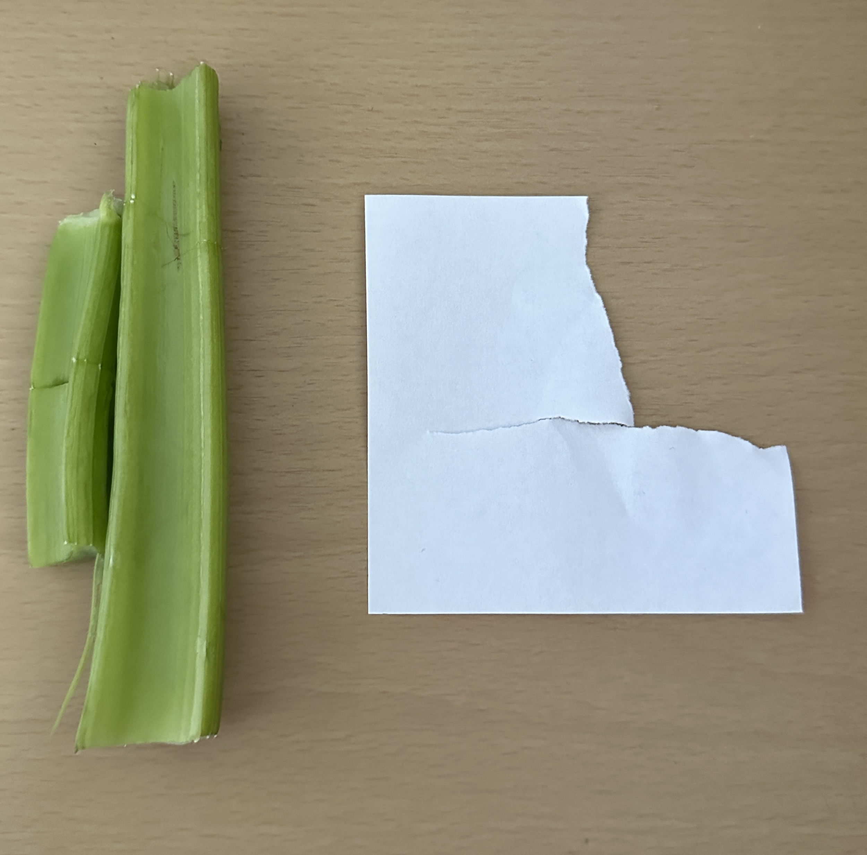

For the big robot’s tracks moving, as well as the gem machines’ tracks moving, I used a layered group of sounds, all created (except for the sub-bass rumble part) through a nail being **dragged** across a **cardboard** **box**, as **shown** **below**:

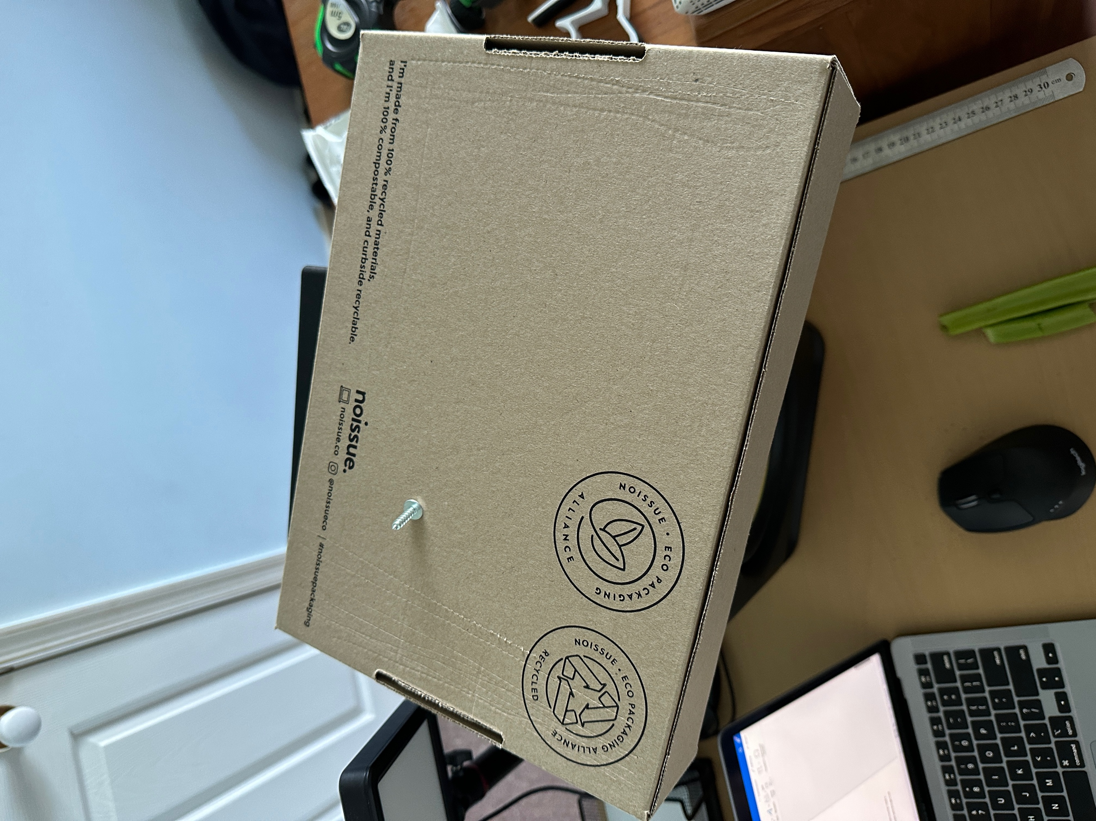

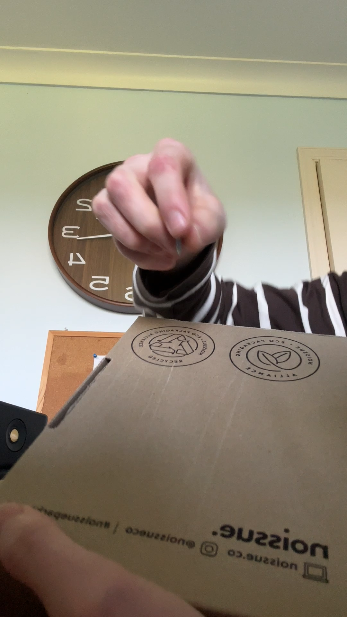Here is a **video** of me **actually making the sound** (I would often pitch it down, distort it and low pass the sound when using it for the big robot’s and gem machines’ tracks):

I also used this sound for a lot of the big robot’s **slow** **movements**, such as its neck turning or body movement – where I would distort it, pitch it up/down and add a tight plate reverb to it (Using the ‘Valhalla VintageVerb’ plugin).

Here is a picture of a number of **other objects** I used for many of the other sounds:

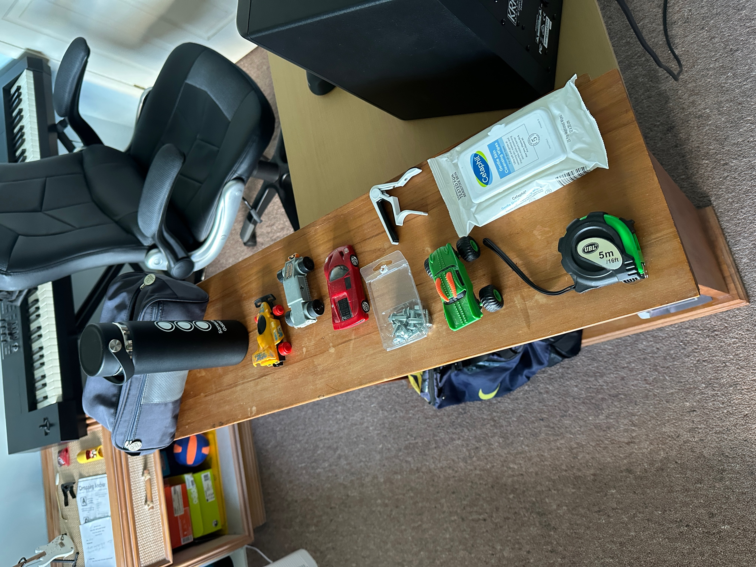

* The **wheels** on these toy cars were used for a number of variations of the wheels for the small robot, as well as the ‘motor’ sound for the big robot.
* Tapping **a flat end of a nail on the** **hydro** **flask** was used for the ‘shiny’ gem sound, as this resonated quite a lot with unpredictable harmonics; where when transposing it in Logic, this matched that of what I felt the trope of a ‘shiny gem’ sounded like (to make it obvious to the viewer (and emphasise) that these gems were something of importance/value).
* The **capo’s** **squeaking** sound (when applying tension) was used for the creaks of the gem machine’s wire (at the start), as well as some of the claw movements for the small robot (pitched up/down often with different EQs added to shape the timbral quality of each sound it was used for).
* The **Cetaphil** **wipes** **packet** was used in combination with the toiletries bag (with some travel soap bottles in it) to create the sound of the small robot’s body movement. The ‘crunch’ of the Cetaphil wipes packet was mainly used for the high end of the sound, whereas the bottles moving in the toiletries bag was used for the mids and low end of the sound.
* For some of the small robot’s body movements, I also added another layer of **the nails and bolts moving in the plastic box/packaging** (that they came in), to add more colour and detail to the mids and high end of the robot’s body parts rattling whilst it moved.
* The **toy** **car’s** **wheels** were also used in combination with the **measuring** **tape** sound to create the sound of the wiring being ‘reeled in’ towards to gem machine. Originally I recorded these as ‘one-shot’ type sounds, and then looped them at specific points to create the feeling of a machine’s cogs cycling through over and over when reeling the wire in (as explained in the ‘Foley’ section above).
* The **heads** of **two** **flat** **nails** were rubbed together to create the metallic sounds for the small robot during close-up shots, such as its claw movements, moving its arms, and when picking up a gem (again, almost always with pitch transposition, EQ and some of the same tight plate reverb applied).